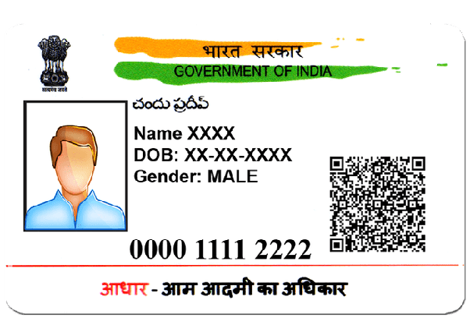

NAME

NAME CHITRA

DOB 07|12|2008

GENDER FEMALE

0000 1111 2222anan